# Swift与Cocoa框架开发

## Day01-开发一个简单的swift应用

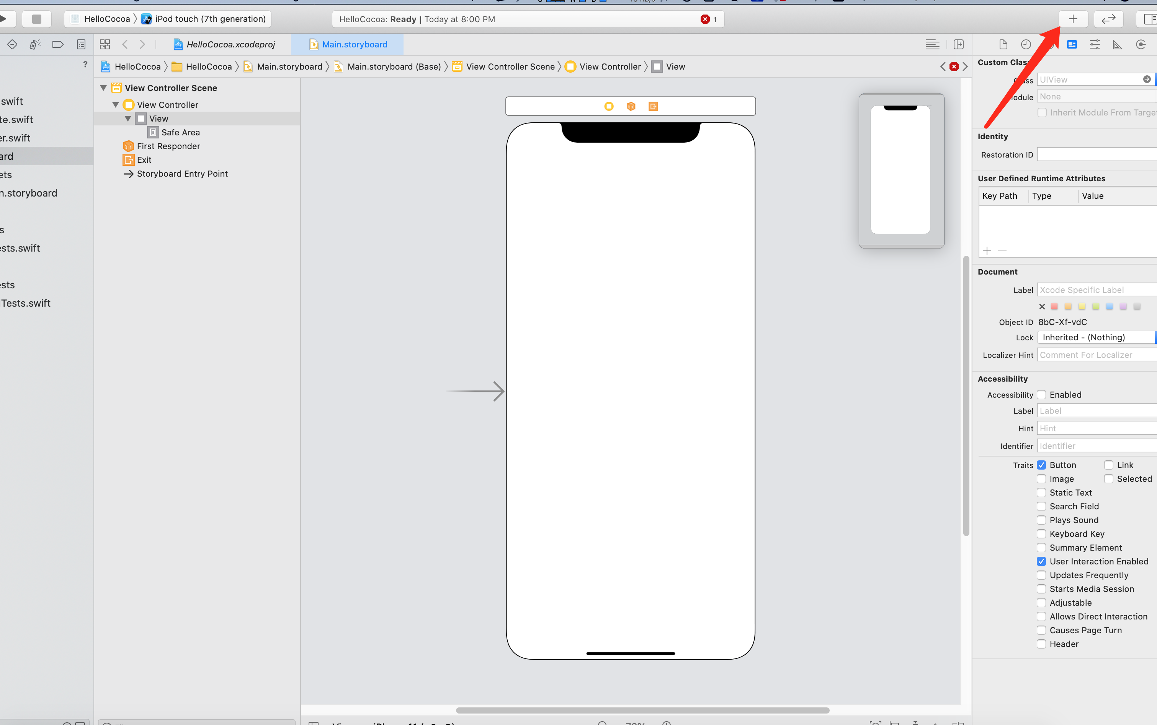

添加控件

<https://developer.apple.com/forums/thread/123079>

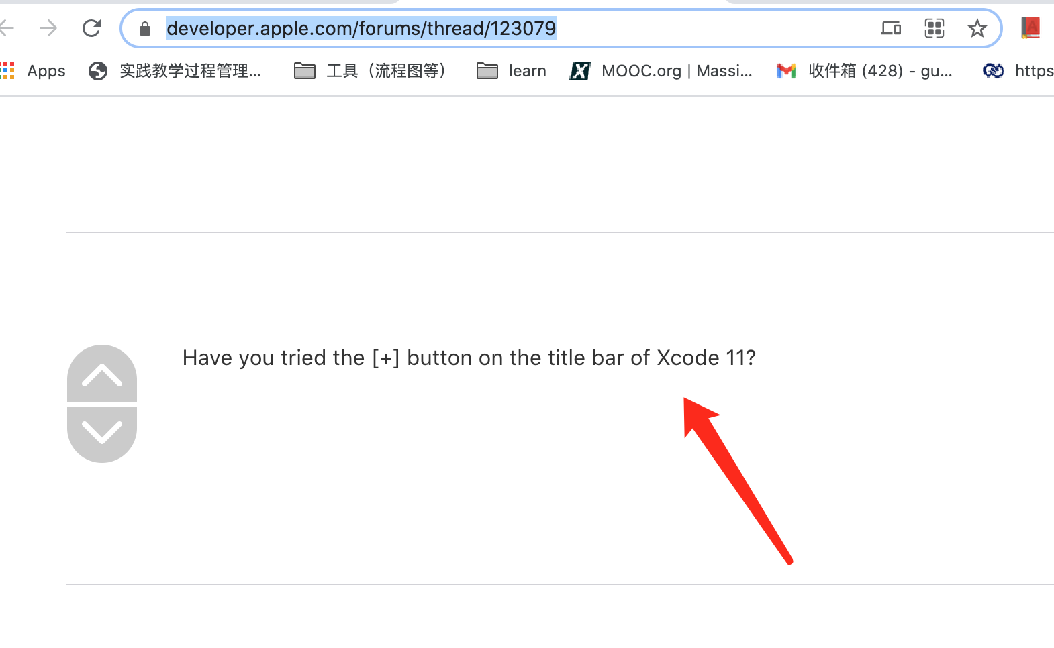

### 显示 assistant editor

<https://stackoverflow.com/questions/56675698/show-assistant-editor-missing-in-xcode-11/56676238>

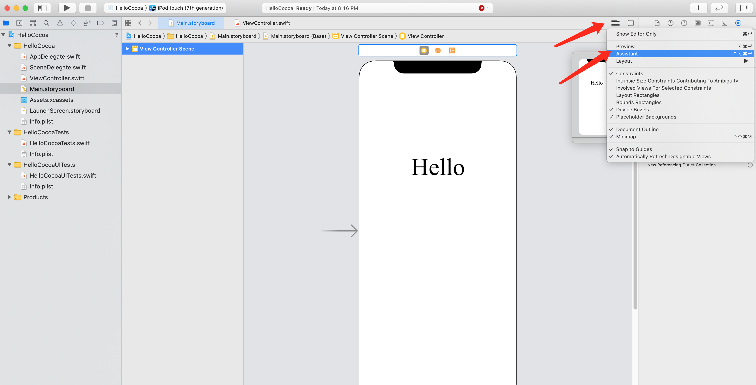

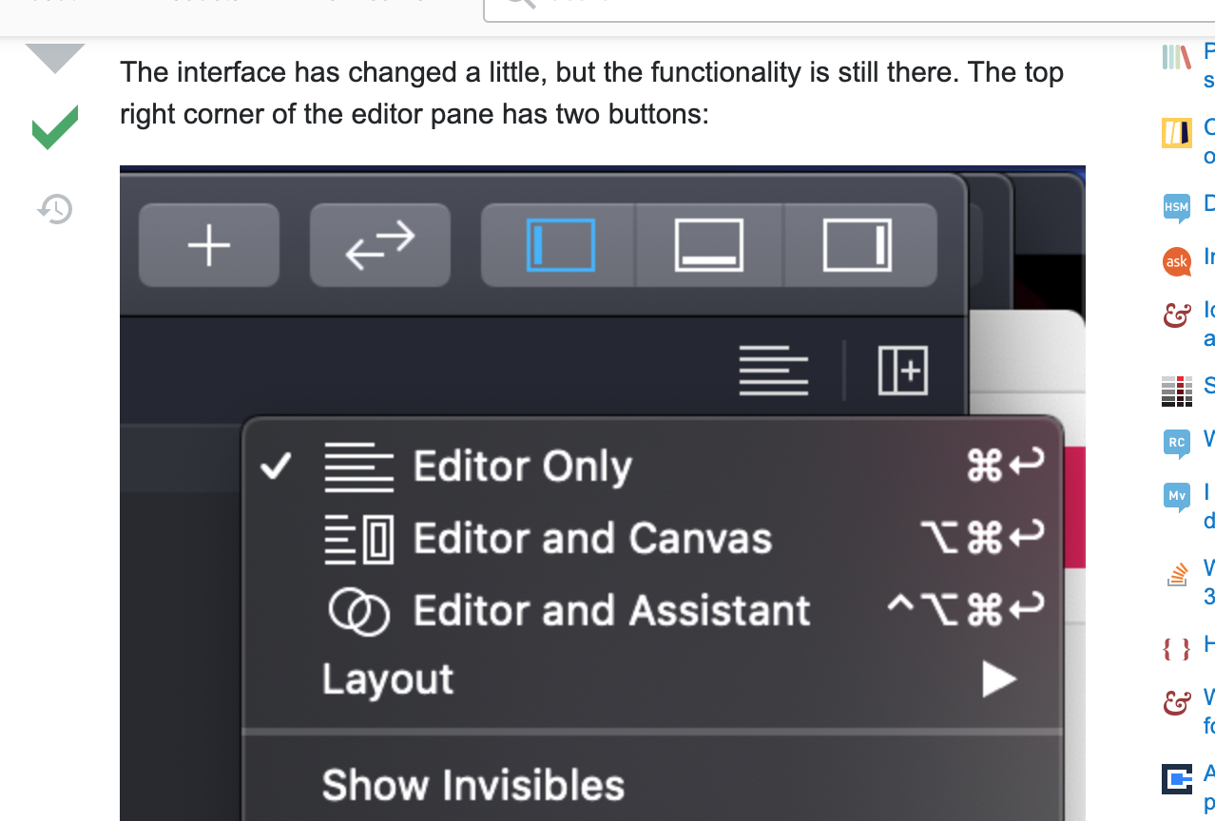

### setTitle("Clicked",for: [])的改变

本来：self.helloButton.setTitle("Clicked", forState: UIControlState.Normal

现在：setTitle("Clicked",for: [])的改变

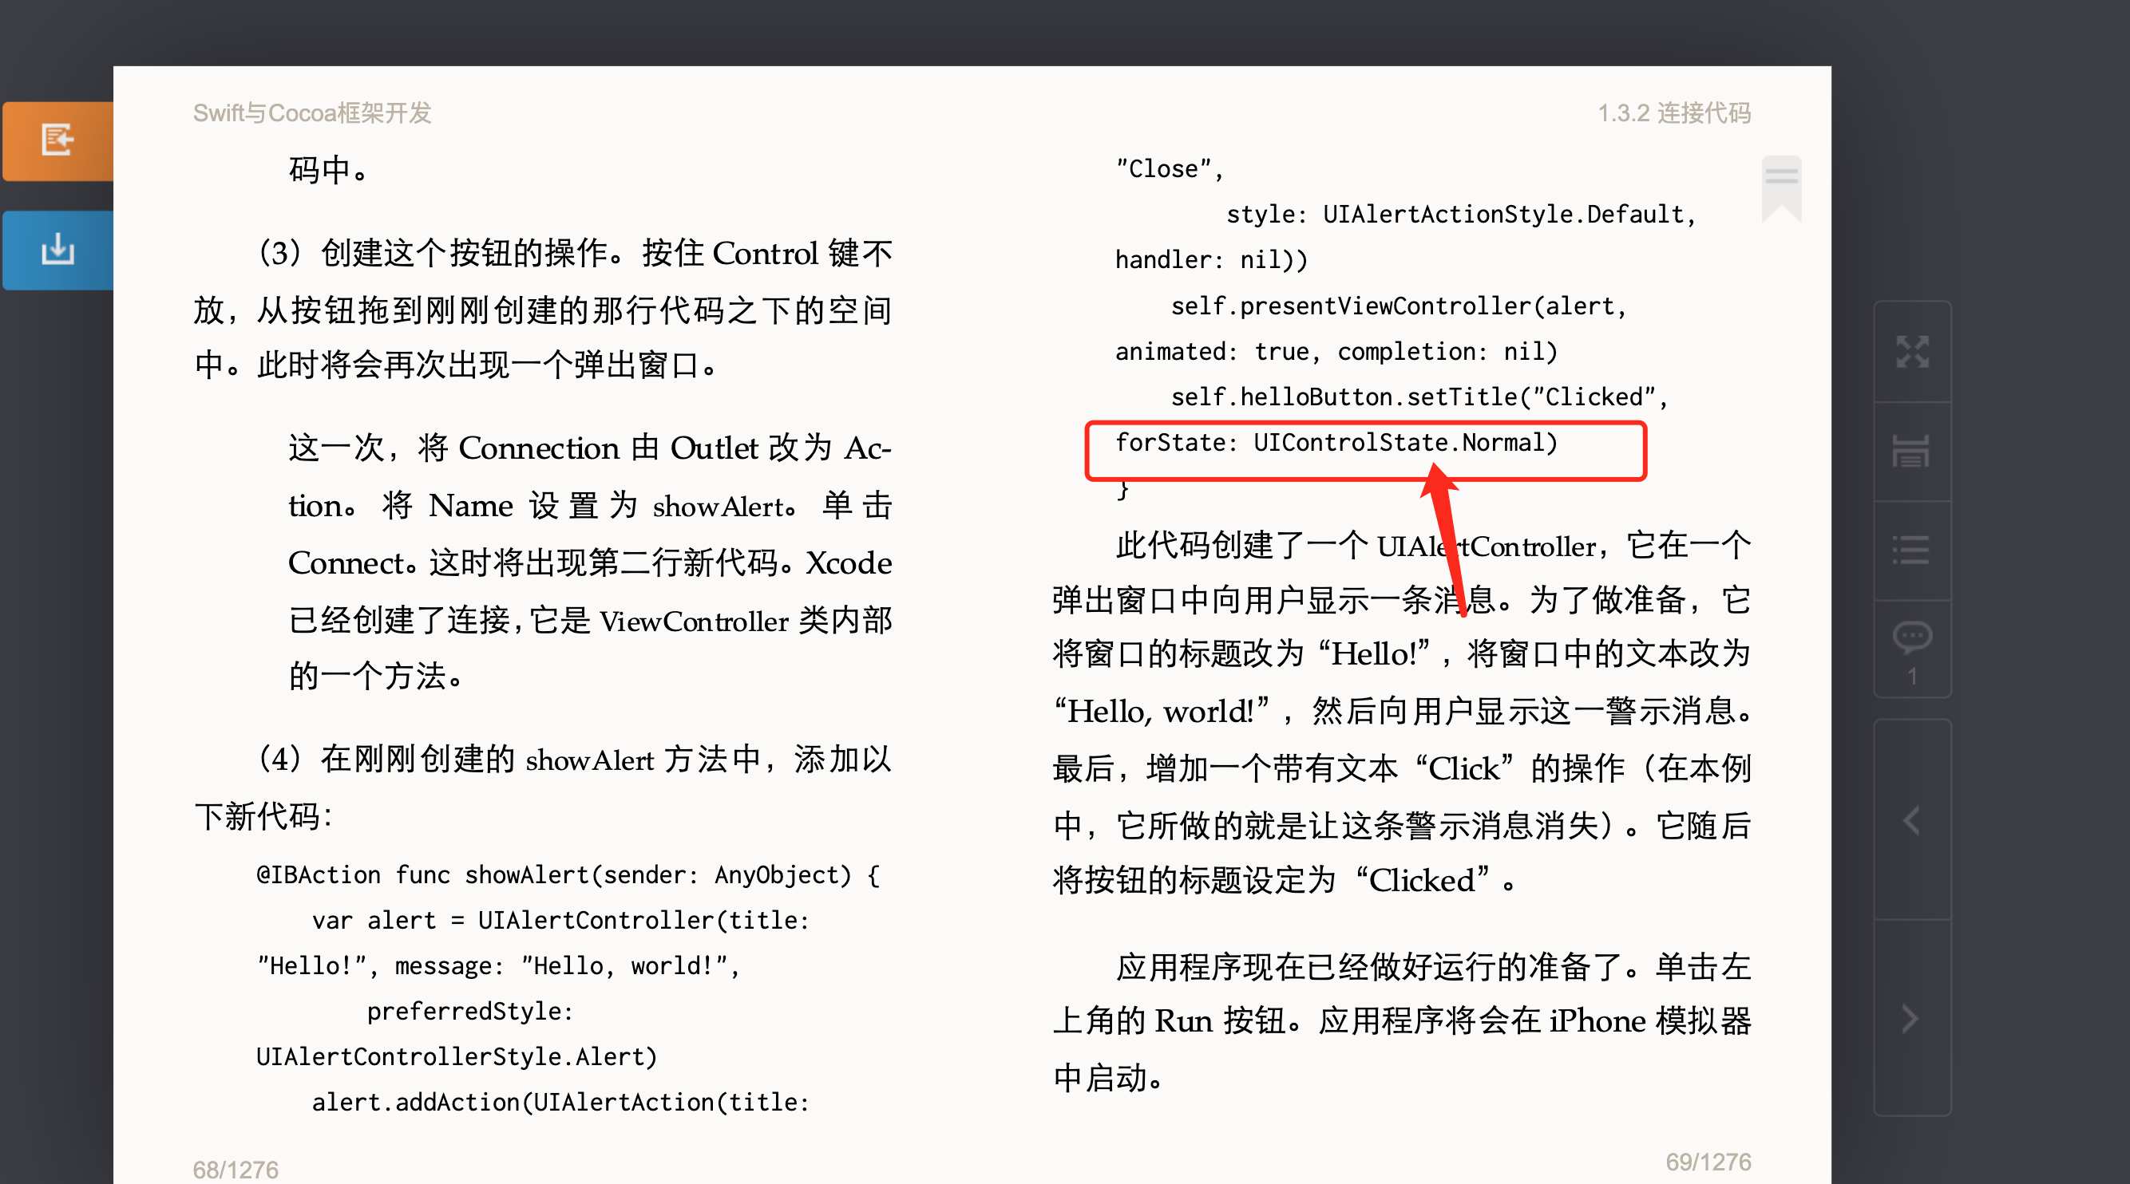

<https://stackoverflow.com/questions/37800342/uicontrolstate-normal-is-unavailable>

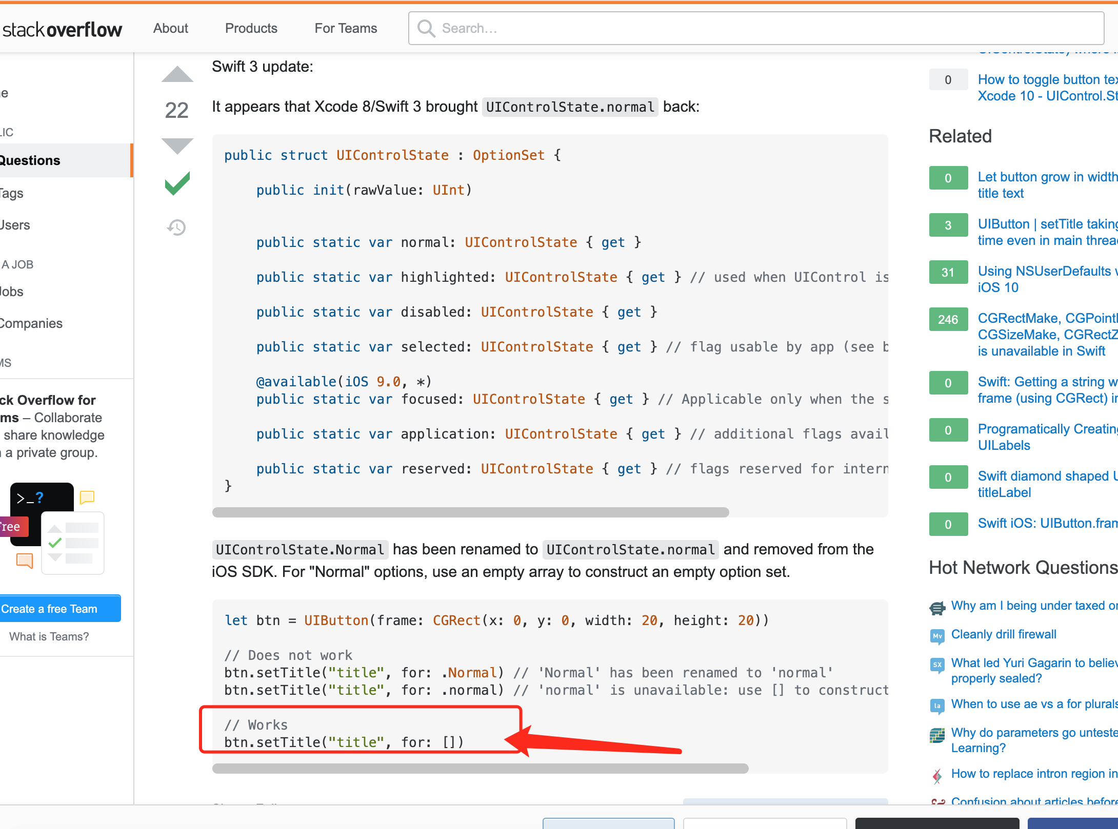

语法大改，变成了这样

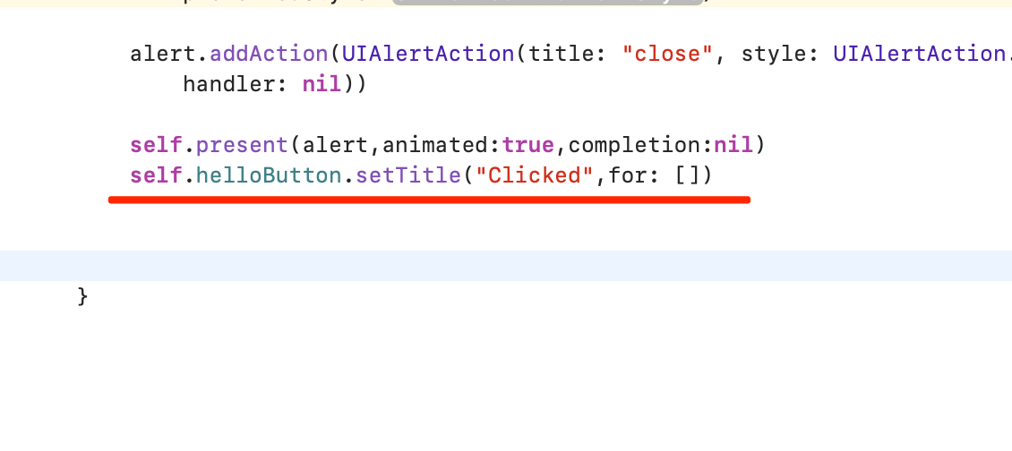

### 一些调试过程

#### Making alert 方法已经改变

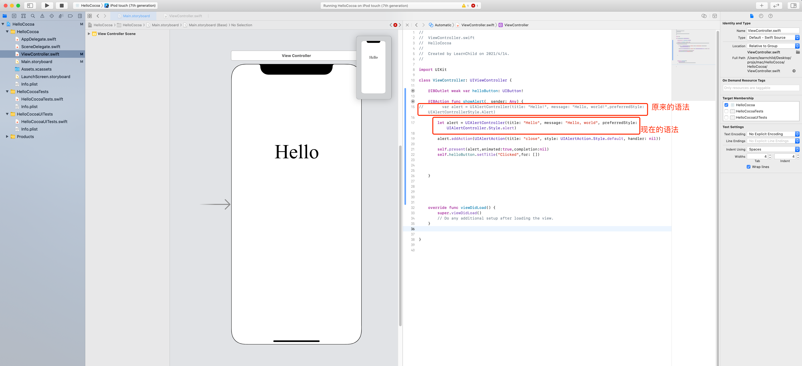

<https://suragch.medium.com/making-an-alert-in-ios-ac36ed5af6d6>

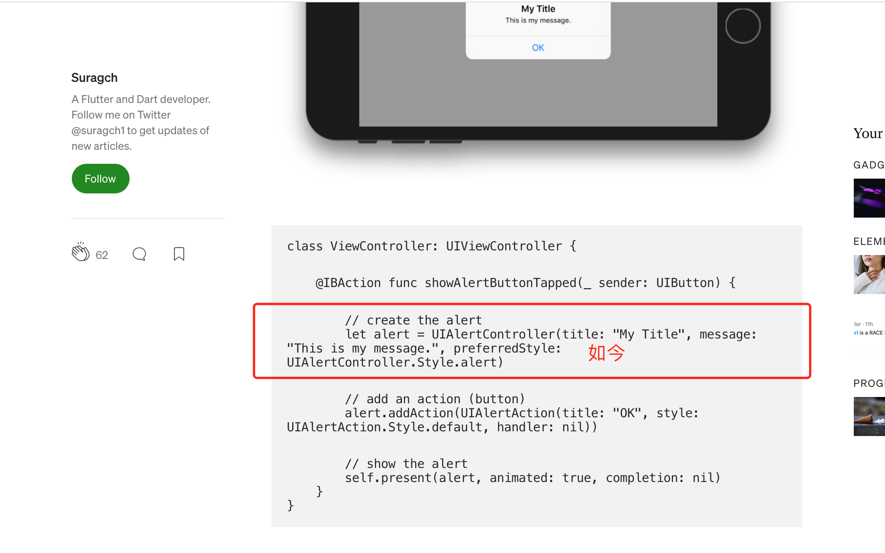

#### Key Commands报错

Key Commands must all have a Title, Key, and Selector. Select each row in the table to check its configuration

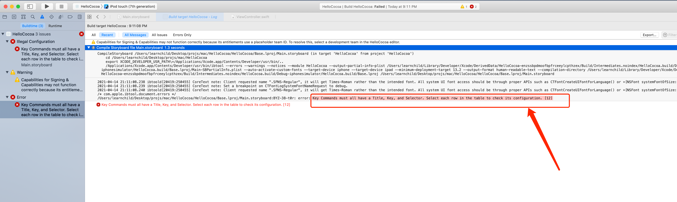

<https://stackoverflow.com/questions/38750691/key-commands-must-all-have-a-title-key-and-selector>

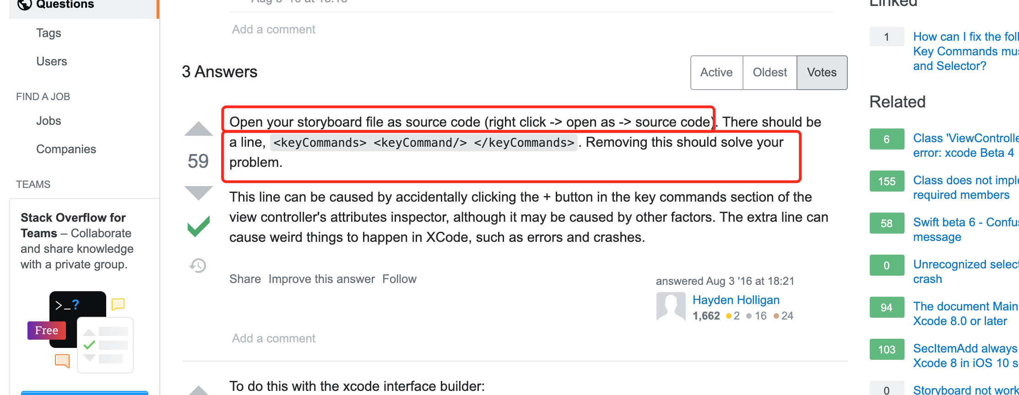

打开故事板源码，

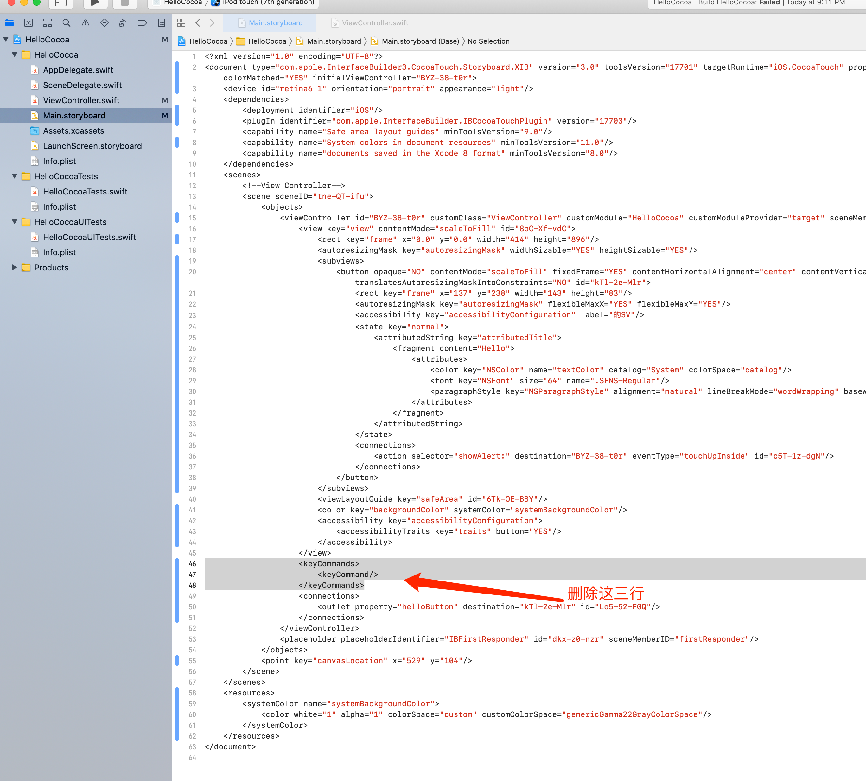

### 成功！

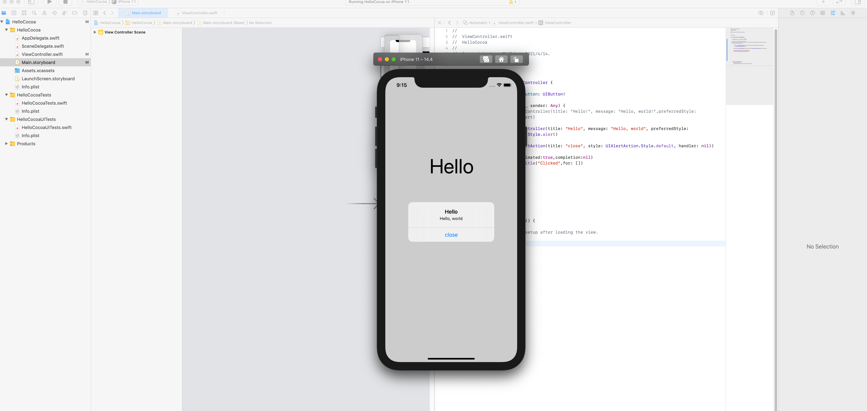

## Day01-✅问题

### ✅文字点击完之后没有【改变title】

<https://stackoverflow.com/questions/35933441/swift-set-uibutton-title-regardless-of-state>

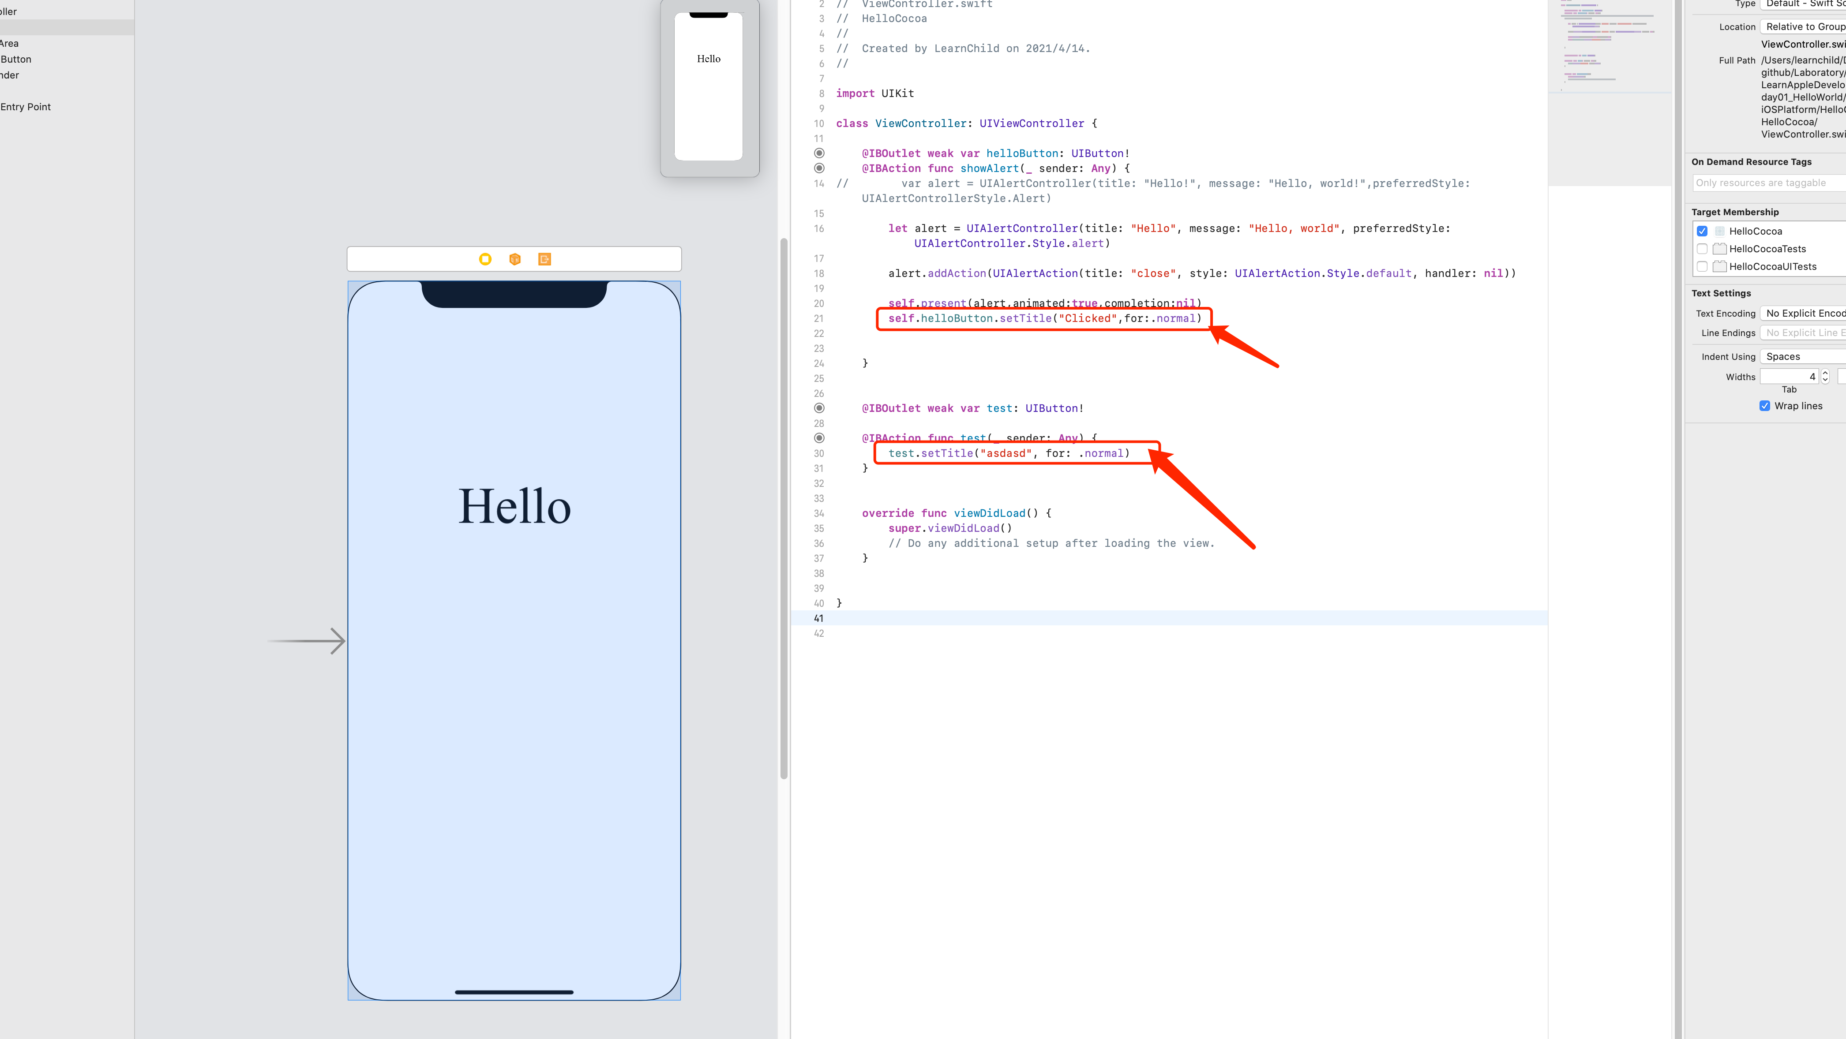

查遍了方法都不行

<https://developer.apple.com/documentation/uikit/uibutton/1624018-settitle>

官方文档也不行👆

#### 原因：UIButton title 的 属性问题，

1. Plain 适用于 setTitle 方法
2. Attributed 适用于setAttributedTitle 方法

#### **完整解答👇**

<https://stackoverflow.com/questions/67102948/swift-5-uibutton-title-didnt-change/67107680#67107680>

我自己的答案 Gin

参考链接

<https://stackoverflow.com/questions/27624890/how-do-you-set-an-attributed-title-color-for-state-in-swift/42484307>

### ✅ui控件未连接报错

异常报错

[libc++abi.dylib: terminating with uncaughtc exception of type NSException (lldb)](https://stackoverflow.com/questions/26442414/libcabi-dylib-terminating-with-uncaught-exception-of-type-nsexception-lldb)

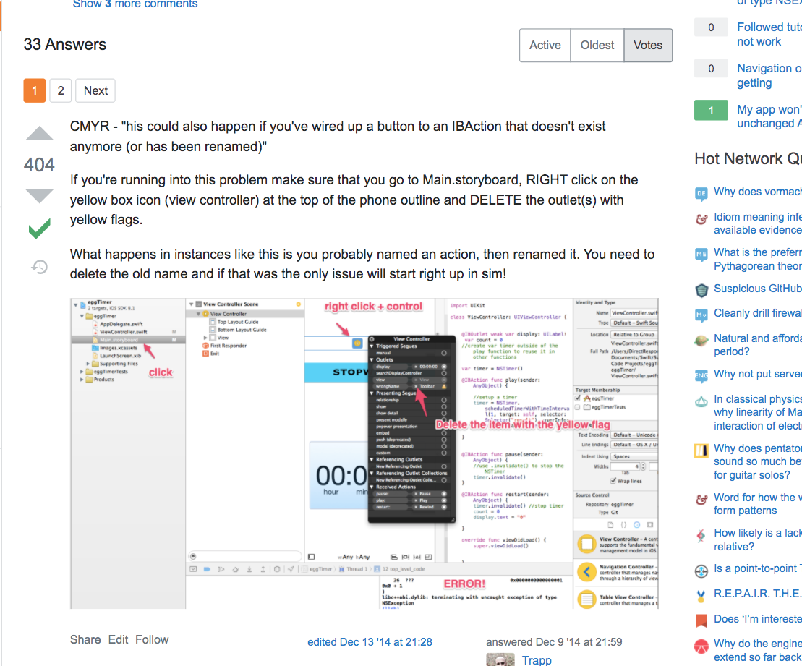

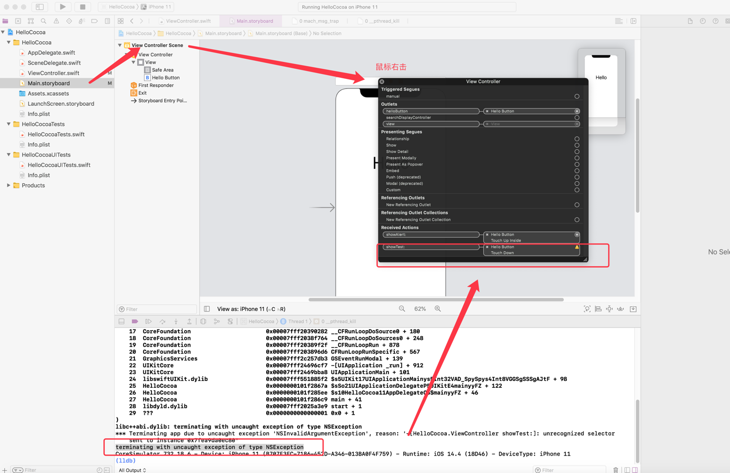

## Day02

### Where is the playground in xcode12?

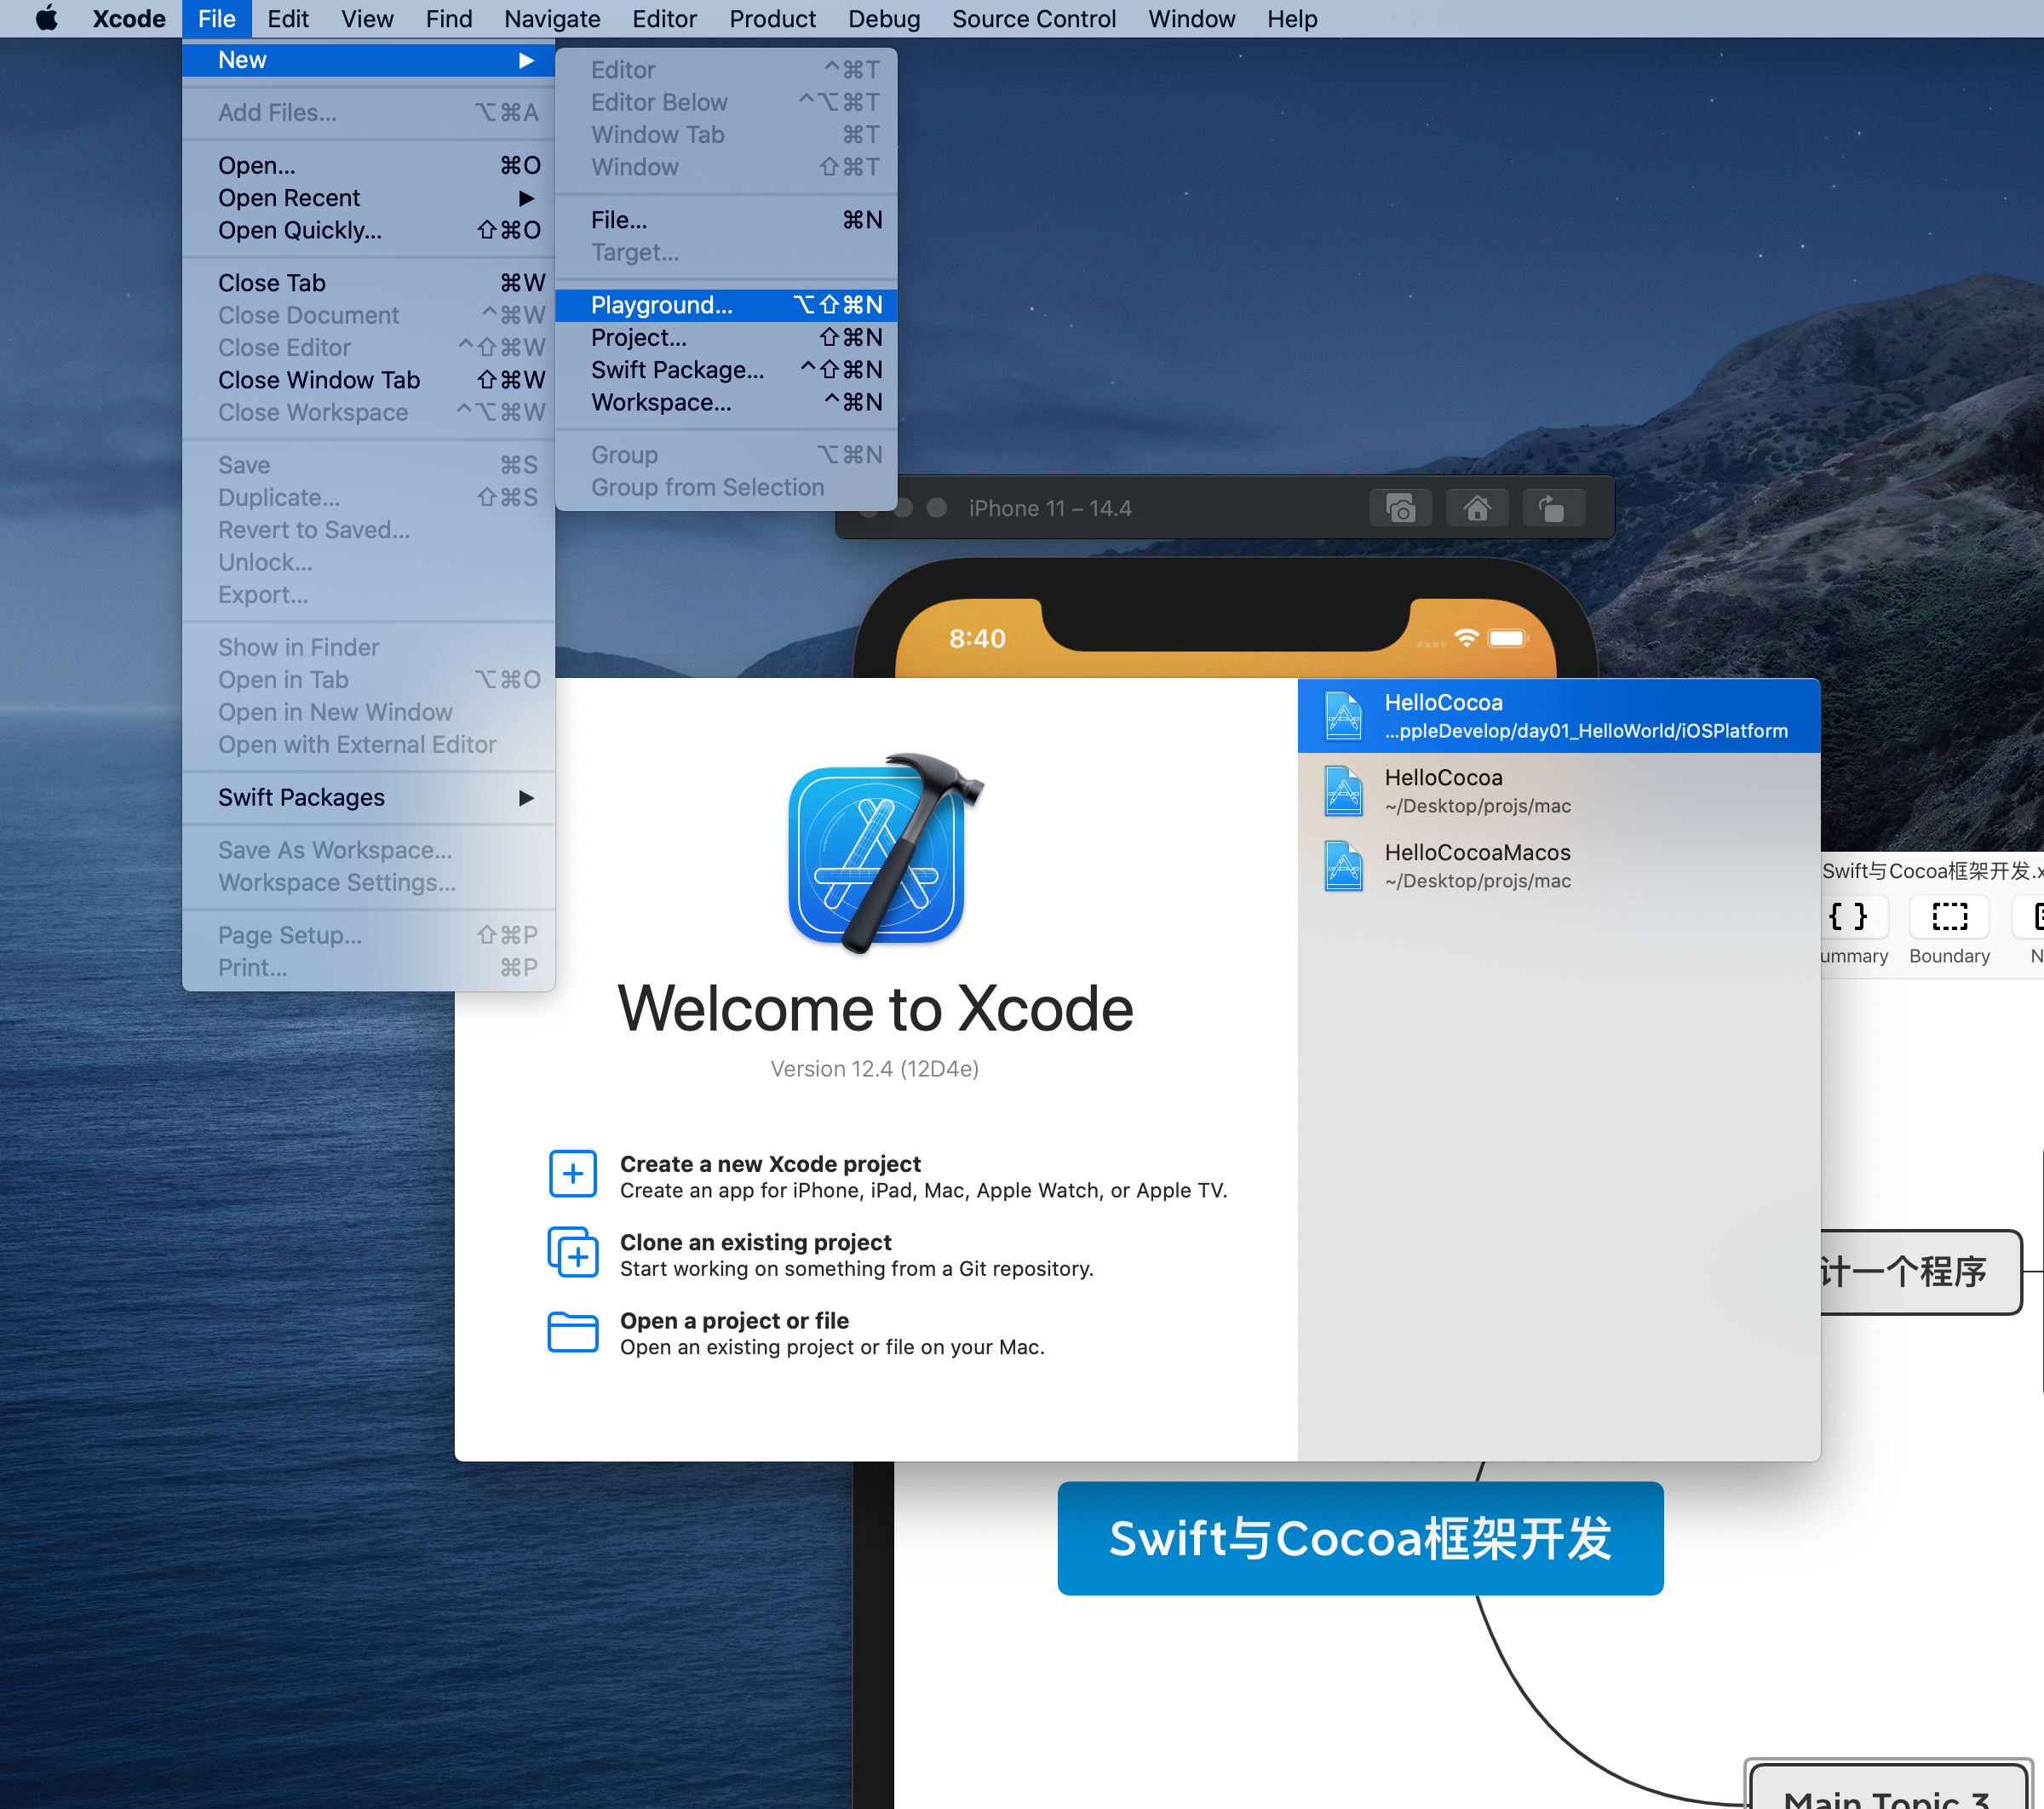

Not in 「start interface」

# ✅Git方面

## 【Git 仓库】嵌套【子仓库】导致检测不到的临时方案

<http://jartto.wang/2017/12/28/cannot-nest-git-repository/>

1. 删除 子仓库的 .git 文件
2. 把 子仓库文件夹 移到涉及git文件夹的外面
3. 把原来的仓库 重新推到 远程
4. 把未追踪的文件夹放回到 git 文件夹
   1. Add
   2. Commit
5. 推到远程分支

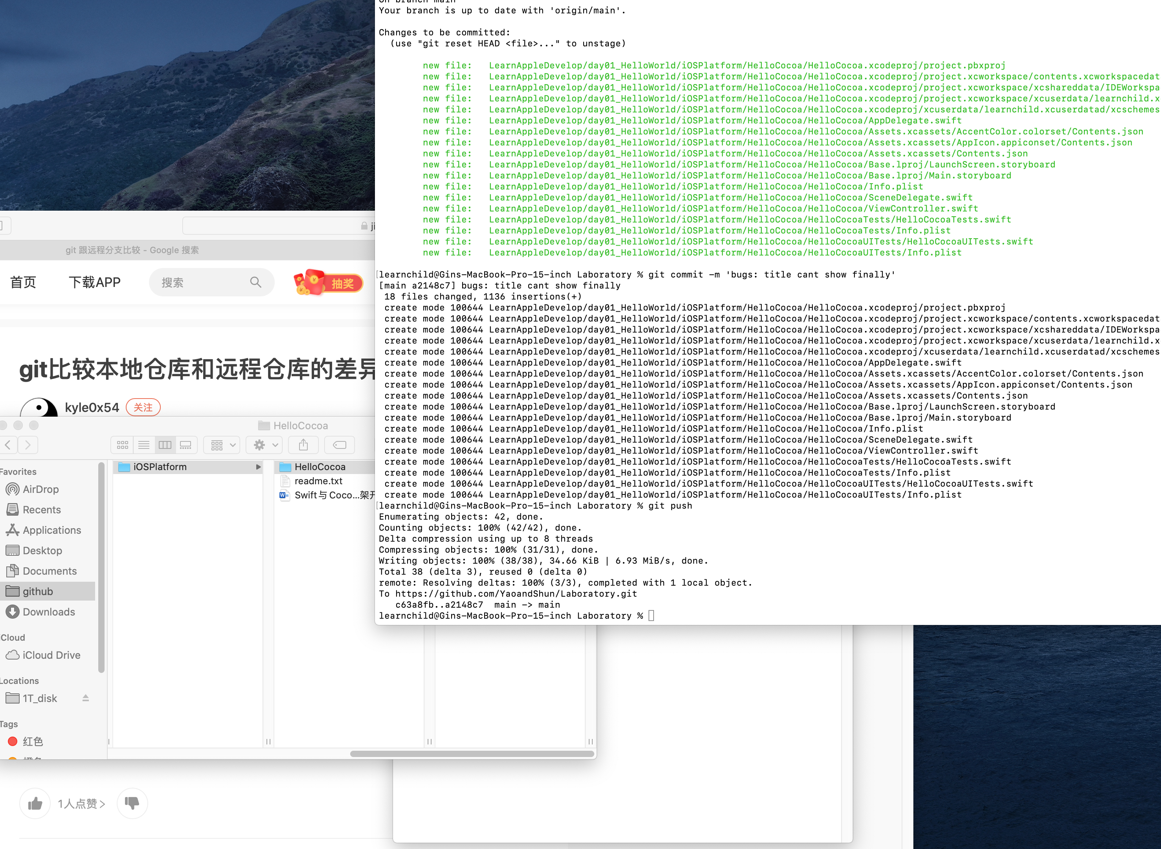

## What is origin/HEAD

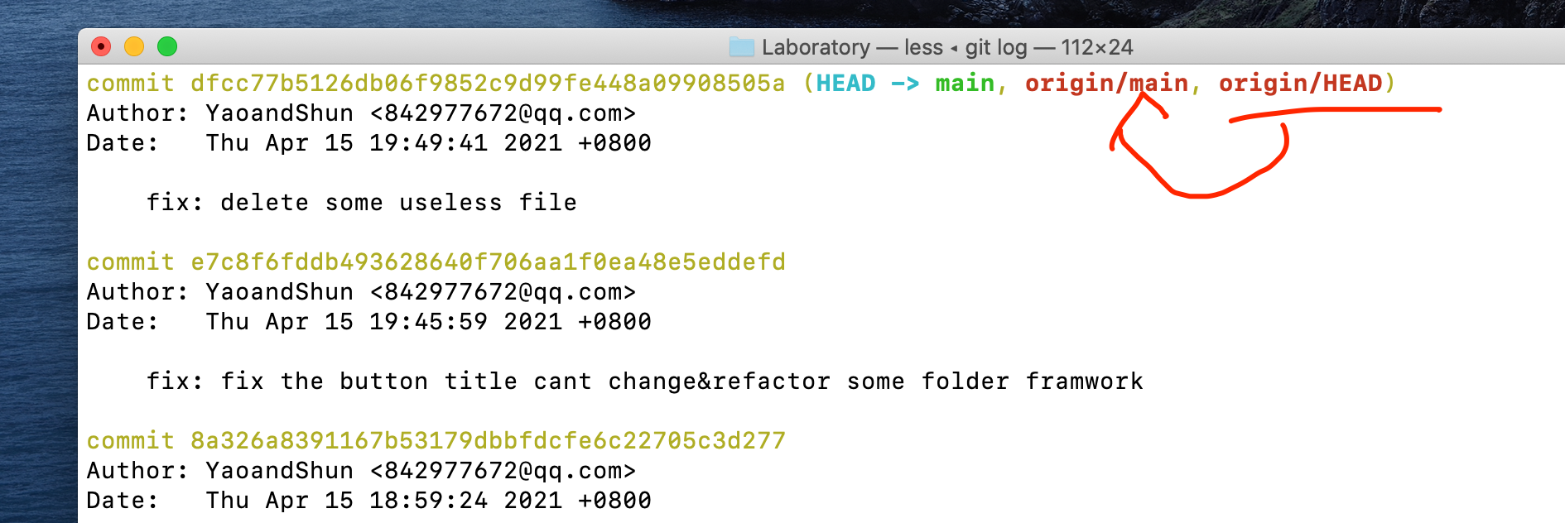

It means remote branch follows the front branch

<https://stackoverflow.com/questions/354312/why-is-origin-head-shown-when-running-git-branch-r>

